AI Assisted Coding (III Year) Assignment
Name: B. Rithwik
HT NO: 2303A52330
Batch: 35

Lab 16 – Database Design and Queries (AI Assisted)

Lab Objectives
- Use AI to assist in designing and implementing fundamental data structures in Python
- Learn prompt-based structure creation, optimization, and documentation
- Improve understanding of Lists, Stacks, Queues, Linked Lists, Graphs, and Hash Tables
- Enhance readability and performance with AI-generated suggestions

Task 1 – Student Information System Schema

1. AI Prompt Used

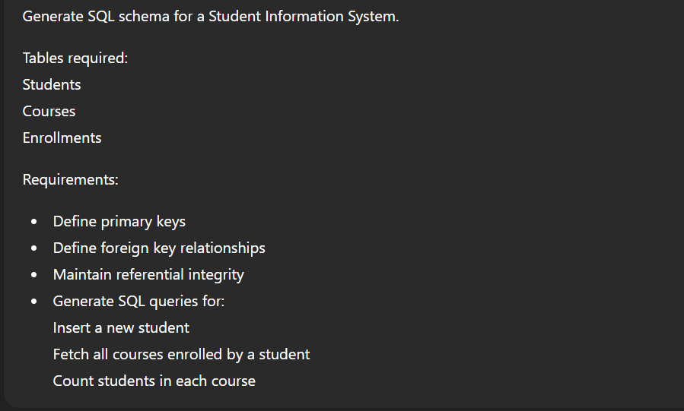
CODE and OUTPUT:
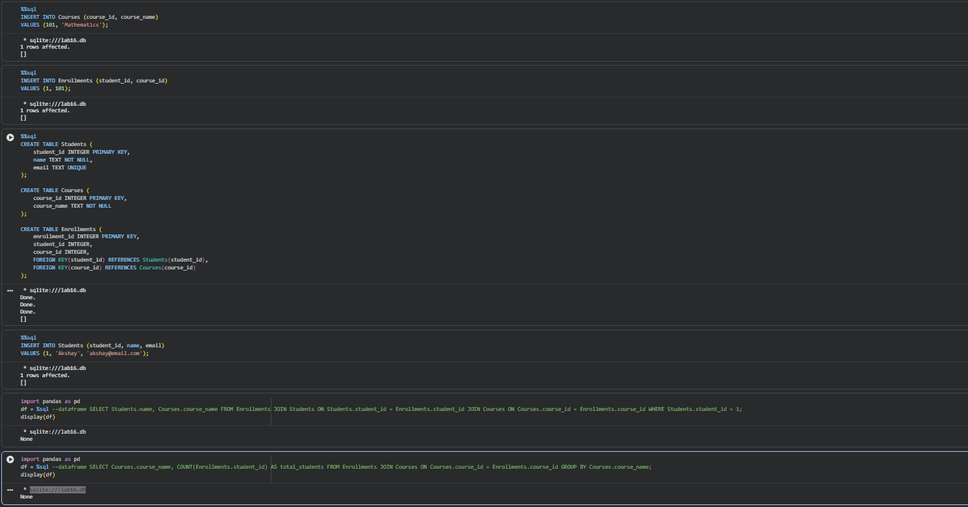
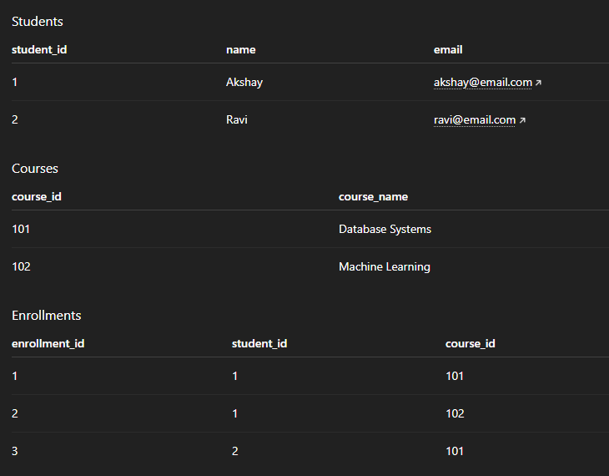

Task 2 – Hospital Management Database
AI Prompt
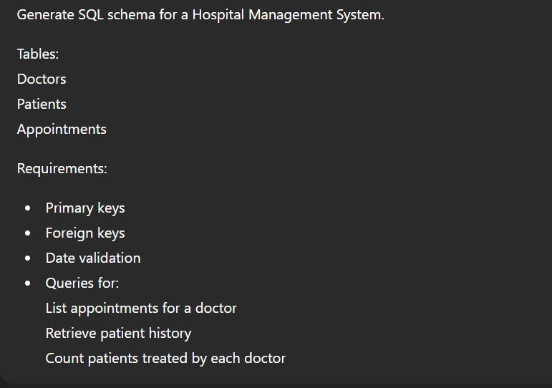
Schema AND Output:
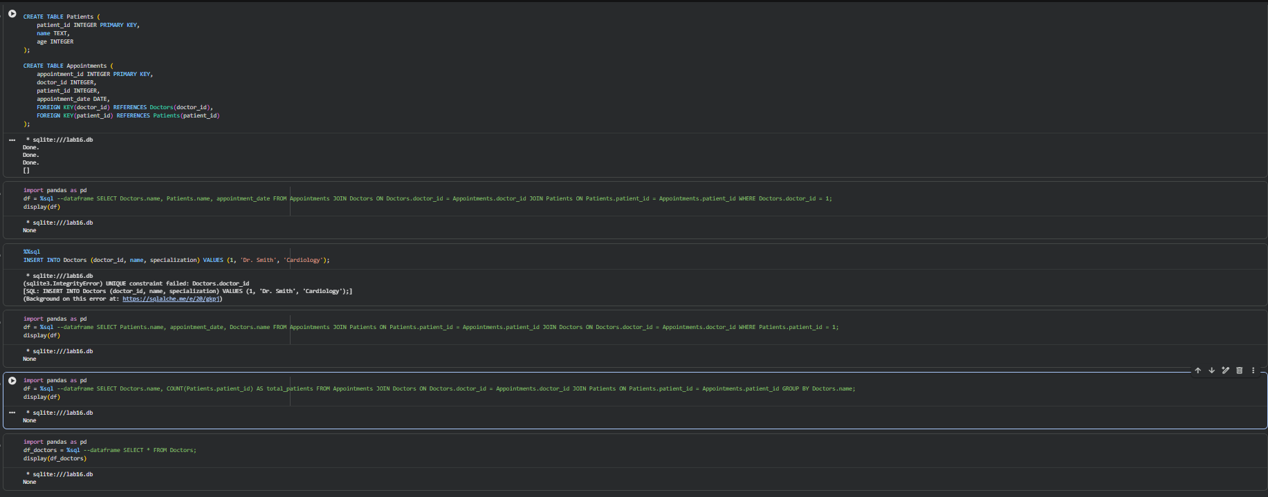
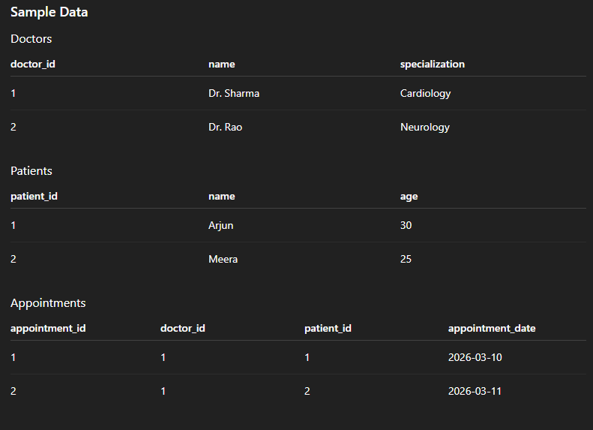

Task 3 – Library Database
AI Prompt
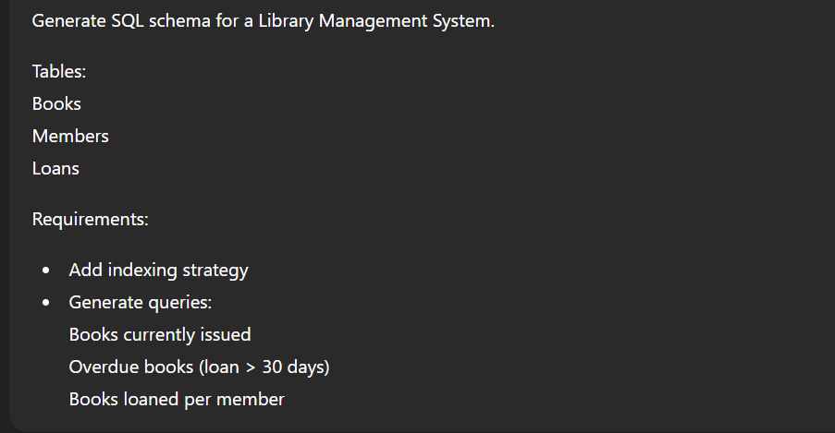
CODE and OUTPUT:
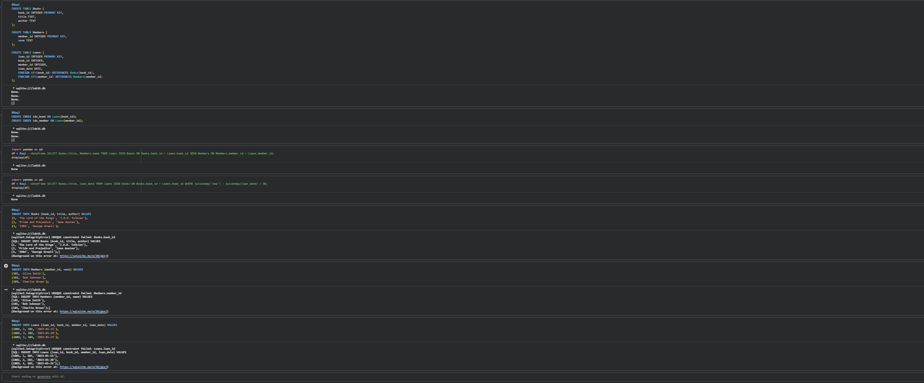
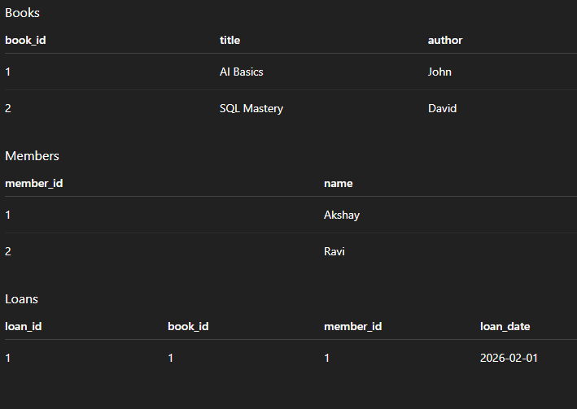

Task 4 – Online Shopping Database
AI Prompt
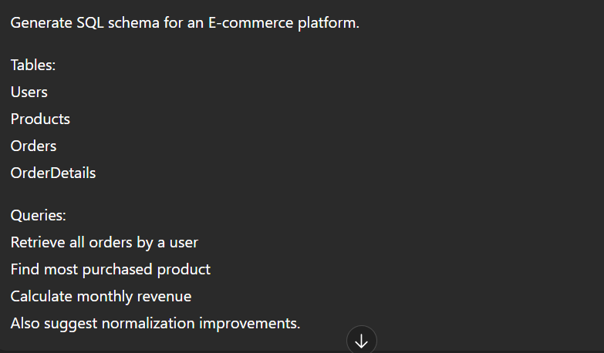
CODE and OUTPUT:
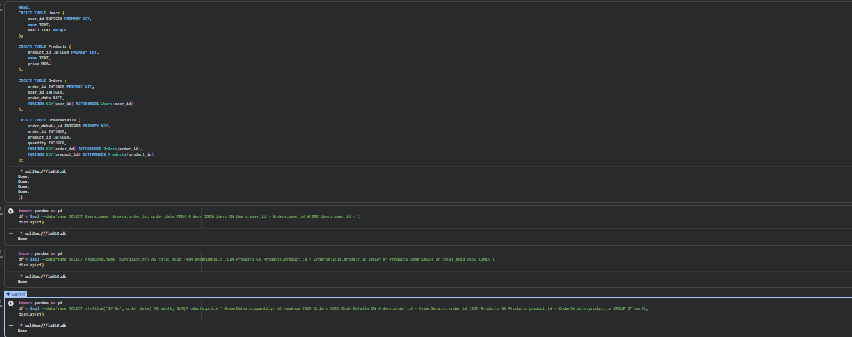
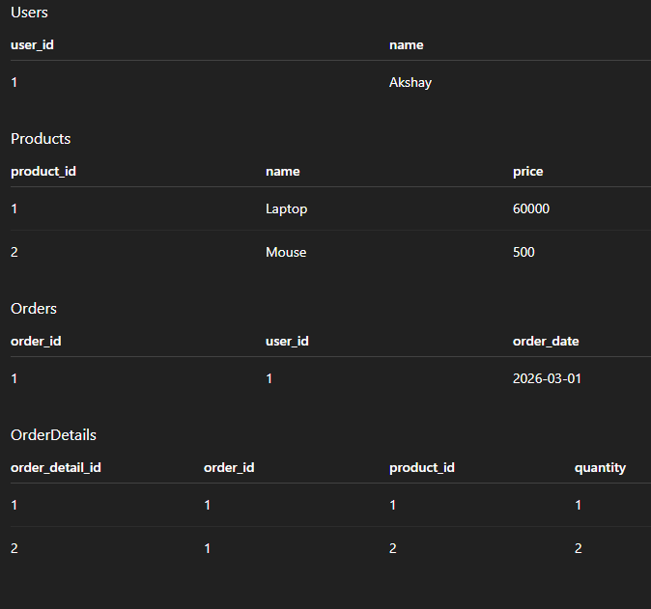

Task 5 – University Examination Database
AI Prompt:
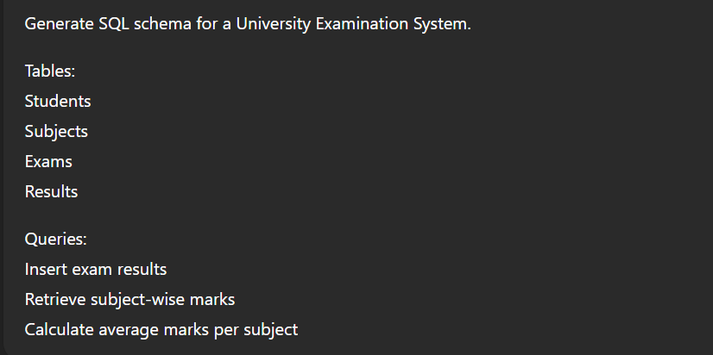
CODE and OUTPUT:
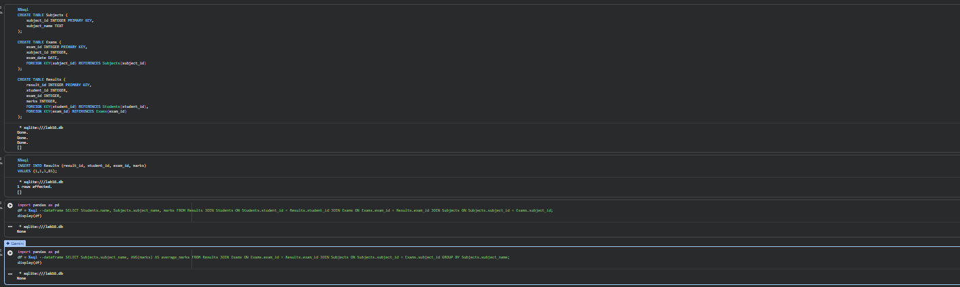
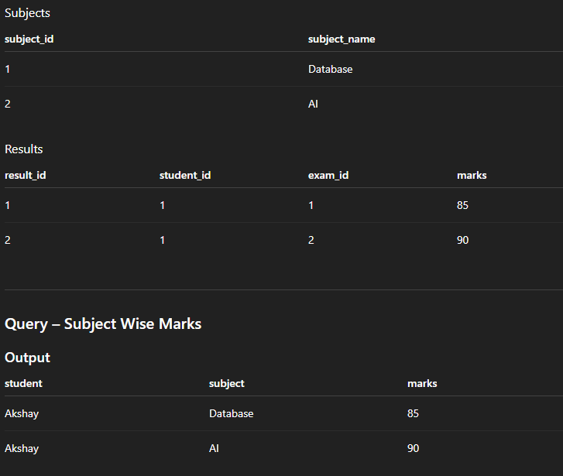

Final Analysis
The experiment demonstrated how AI can assist in designing relational database schemas and generating SQL queries. Multiple database systems were modeled including Student Information Systems, Hospital Management Systems, Library Systems, E-commerce platforms, and University Examination Systems. SQL queries demonstrated CRUD operations, joins, and aggregate functions. Normalization principles and indexing strategies were applied to improve data integrity and query performance.

